The ea open a trade based on the trend direction and then at the same time open a opposite buy / sell stop trade for the same value that will initiate as an hedge as soon as the trend flip.
As soon as the stop order is triggered then open another stop order double the open trade value in the opposite direction. The stop orders are set to tick closer as the direction move away from it.

To get meaningful backtest analysis you need to either:
- Run the test long enough for trades to close, then the bt_*_trades.csv will have real data to work with
- Or I can write a Python script now that reads the trades CSV after a completed run and computes win rate, average profit/loss, profit factor, equity curve, and drawdown — ready for when you do have closed trade data

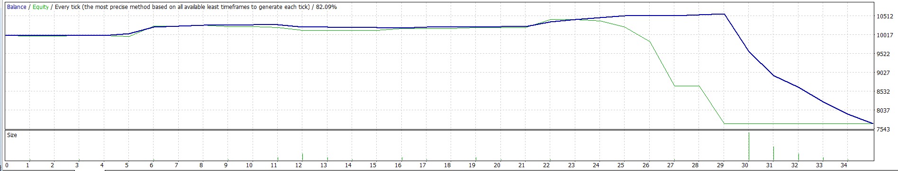

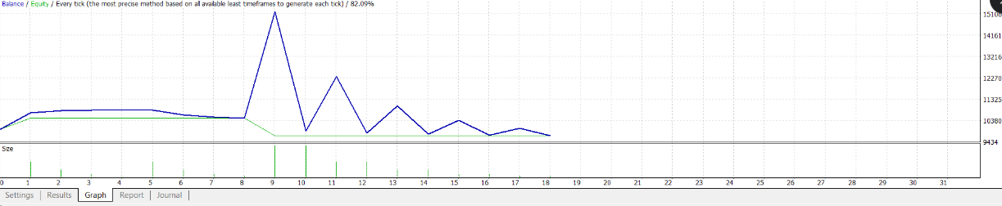

The EA is ready. Here's exactly what changed and why:
Root cause of the identical curves: The sell basket close (Mechanism 2) was running at position 533 in the function — it harvested profitable SELLs for tiny gains ($64) while the BUY martingale was already -$142. The combined close at position 537 then ran but found zero SELLs and did nothing. The SELLs that should have been the BUY hedge were stripped away first.
What changed in ManageTradeClosures():
BEFORE (function priority order):
1. 1B+1S check
2. ≥2 buys close ← harvests buys individually
3. ≥2 sells close ← harvested the SELLs for $64 while BUYs were -$142
4. Combined close ← ran too late, SELLs already gone

AFTER:
1. Combined net ≥ $50 → close ALL (new Priority 1)
2. Combined net < 0 → RETURN (hold — don't touch the hedge)
3. 1B+1S check
4. ≥2 buys close ← only fires when combined ≥ 0
5. ≥2 sells close ← only fires when combined ≥ 0
The one-line if (UseCombinedClose && netProfit < 0) return; is the key — when BUYs are in loss and SELLs are profitable, it holds both open so the SELLs can grow until they offset the BUY losses.
Recompile and run the backtest — same settings as before. The journal should now show "Combined net X >= 50 -- closing all" entries instead of individual sell basket closes.
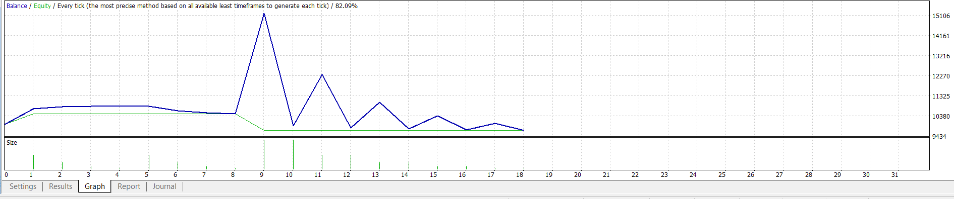image.png1891×396
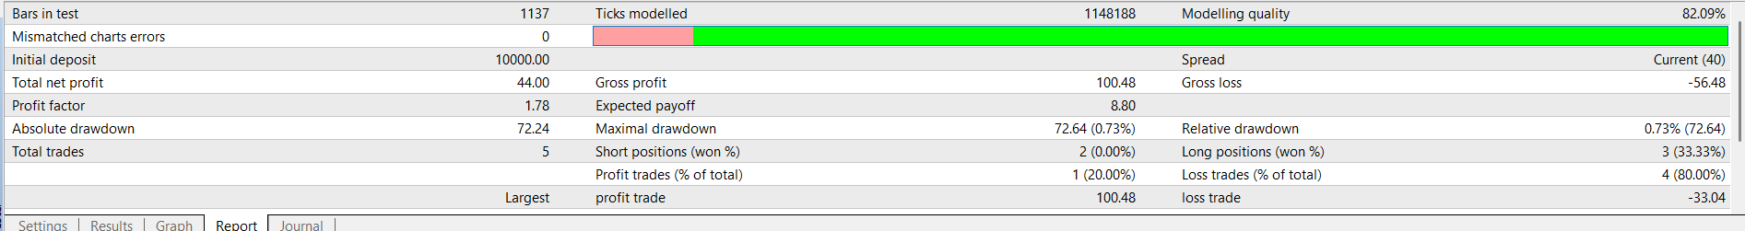
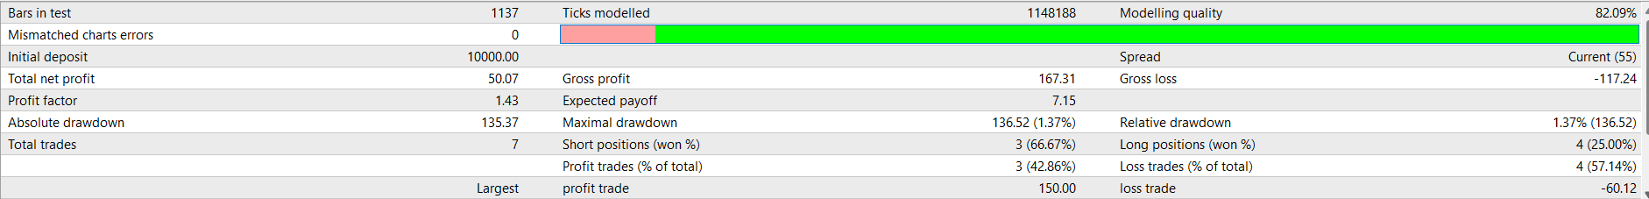
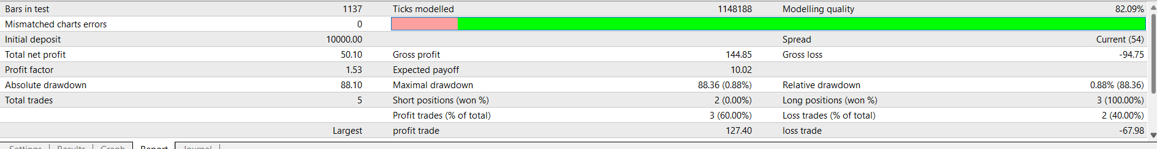
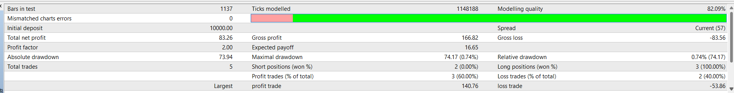
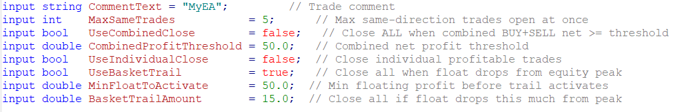
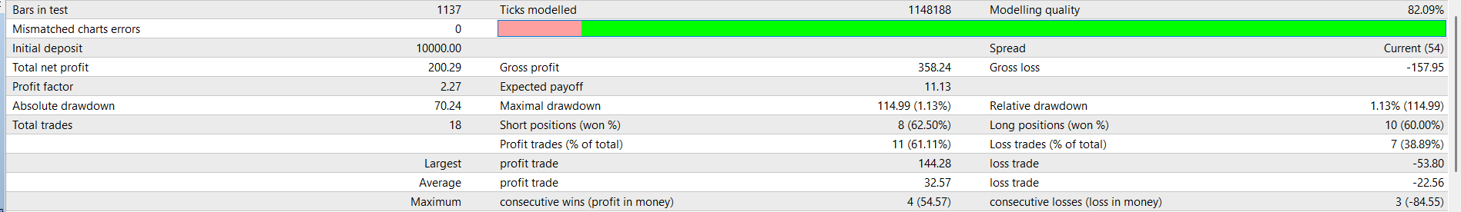
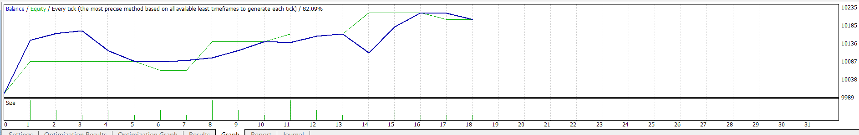
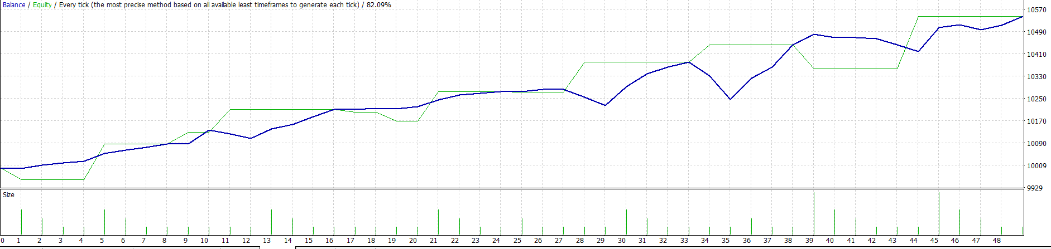
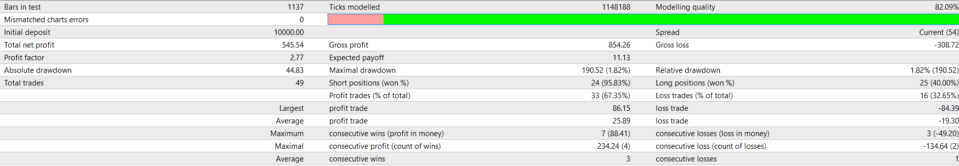
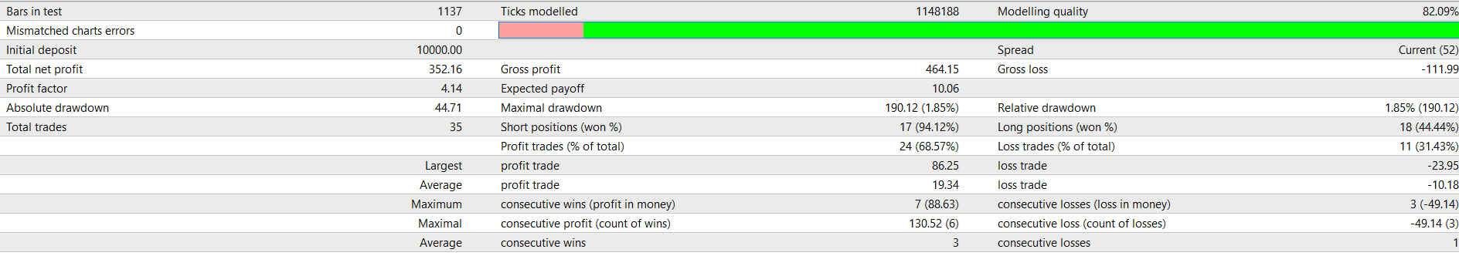

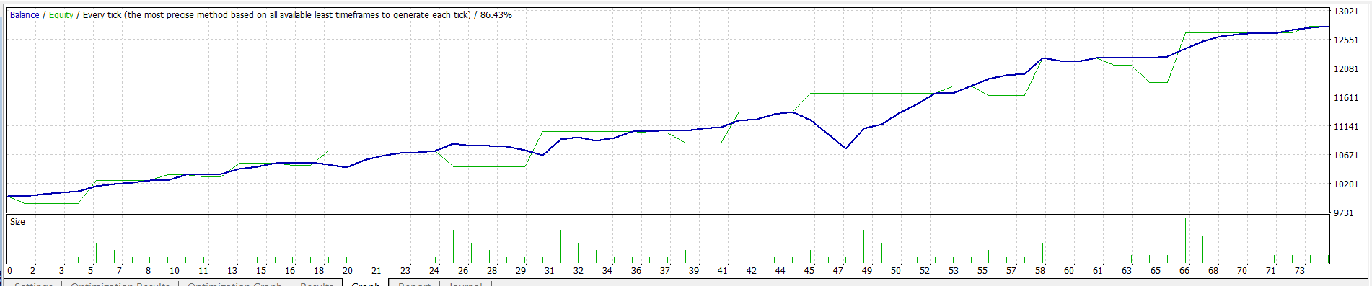
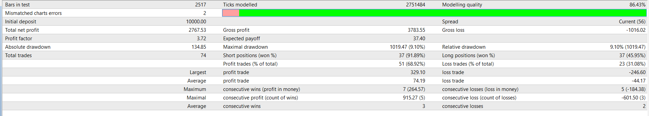
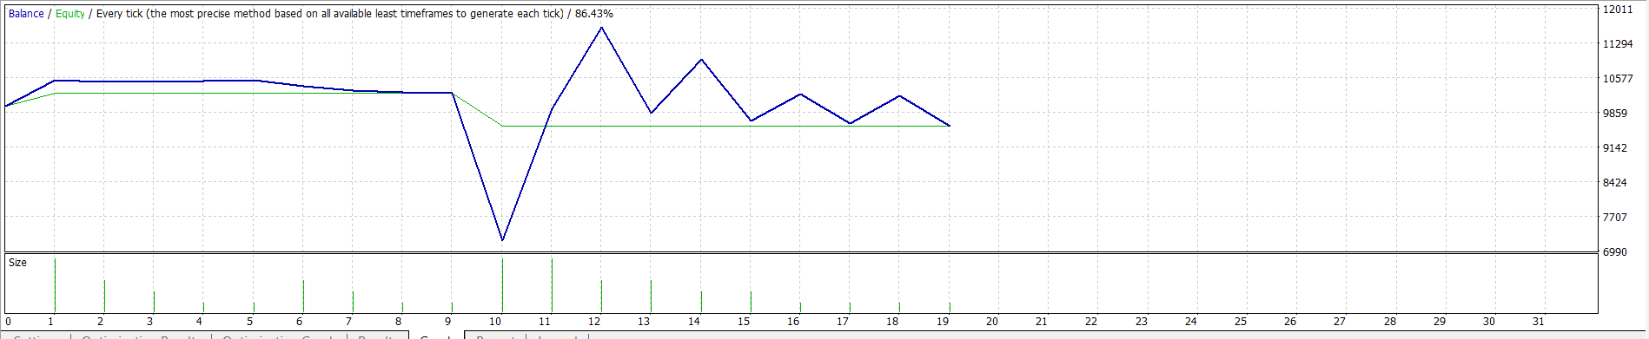
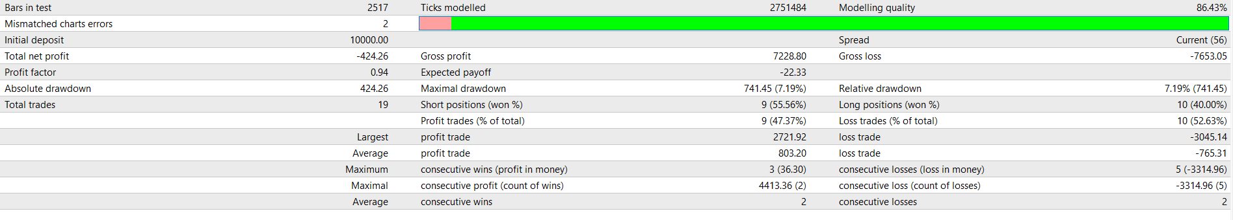
Here are the most impactful changes, ranked by potential effect on long-term performance:

1. Compounding — the biggest dial of all
Currently LotSize = 0.01 forever, regardless of whether the account is $10,000 or $15,000. Compounding fixes this.
Fixed fractional sizing:
LotSize = (AccountBalance / 10,000) × 0.01
Month | Balance | Effective LotSize | Monthly profit (est.)
1 | $10,000 | 0.01 | $547
3 | $11,094 | 0.011 | $607
6 | $12,940 | 0.013 | $708
12 | $16,733 | 0.017 | $915
No strategy change — just let profits fund the next trade size. This alone turns a flat return curve into an exponential one.

2. Session filter — cut bad trades, not good ones
GOLD M5 behaves very differently by session:
Session | GMT | GOLD behaviour
Asian | 00:00–07:00 | Choppy, low ATR — most losing trades
London open | 07:00–09:00 | Strong directional moves
London/NY overlap | 13:00–17:00 | Best momentum
Late NY | 17:00–21:00 | Fading, still tradeable
Adding a simple time filter (TradeStartHour=7, TradeEndHour=21) would block entries during the choppy Asian session. Same strategy, fewer bad entries, better win rate — no lot sizing risk at all.

3. Tiered trailing stop — capture big moves better
Currently the trail is flat: $15 gap regardless of how far the basket runs. Tighten it progressively as profit grows:
Basket float | Trail gap | Effect
$50–$100 | $15 | Current behaviour
$100–$200 | $10 | Locks in more
$200+ | $5 | Barely lets it breathe
A $200 move currently exits at $185 (200−15). With tiered trail it exits at $195 (200−5). On a big GOLD move that's a meaningful difference.

4. Partial close — bank half, let half run
When the basket trail fires, close 75% of positions and leave 25% open with a break-even stop. You bank the guaranteed profit but keep a free ride on any continuation.
- Normal cycle: bank $50, done
- Big move cycle: bank $37 immediately, remaining 25% runs to $150+
This directly addresses the one frustration with the current system — the trail fires and then GOLD continues another 200 points without you.

5. ATR-scaled profit target
Instead of MinFloatToActivate = 50 (fixed), make it proportional to current volatility:
MinFloatToActivate = ATR(14) × TotalOpenLots × 1.5
When GOLD is calm (ATR=80 points), target stays low — exits quickly. When GOLD is volatile (ATR=300 points on big news), target scales up — lets the basket breathe and capture more. Avoids premature exits during high-volatility events.

Priority order for implementation
# | Change | Complexity | Impact
1 | Compounding | Zero — just change how you increase LotSize | Highest long-term
2 | Session filter | Low — 2 new inputs, 1 if-check in OnTick | High — cleaner entries
3 | Tiered trailing | Medium — modify CheckBasketTrail | Medium-high
4 | Partial close | Medium — modify CloseAllTrades | Medium
5 | ATR profit target | Medium — replace fixed MinFloatToActivate | Medium

My honest recommendation: start with the session filter on the demo account — it requires the least code, carries zero additional risk, and you'll see the impact immediately in cleaner entry quality. Then add compounding once you go live and the account starts growing.
Want me to implement the session filter first? It's the lowest-risk, highest-confidence improvement.

Where to improve from here:
- Optimization — grisk=7 delivered this. Worth testing grisk=5 and grisk=9 to see if signal quality improves the buy win rate (currently 47% vs sells at 72%).
- BuySellProfitThresholdInCurrency — The current threshold is 50 × 0.01 = $0.50, which fires almost instantly. Setting it to e.g. $15–$20 in currency would let profitable baskets run slightly longer before closing, potentially capturing bigger moves like the $91 sell on line 180.
- ManageTradeClosures running every tick — currently it only runs when a new trade opens. If no new signal fires for hours, a basket sitting at $30 profit stays open. This is low risk to add now that the sell basket exists.

After grisk is done, run a second pass with the best grisk fixed and optimize these two together:
Parameter | Start | Step | Stop
MA_Angle_Threshold | 10 | 5 | 30
ADX_Threshold | 15 | 5 | 30
This two-pass approach keeps the optimization space manageable — 8 grisk values first, then 15 combinations for the angle/ADX pair once grisk is locked in.

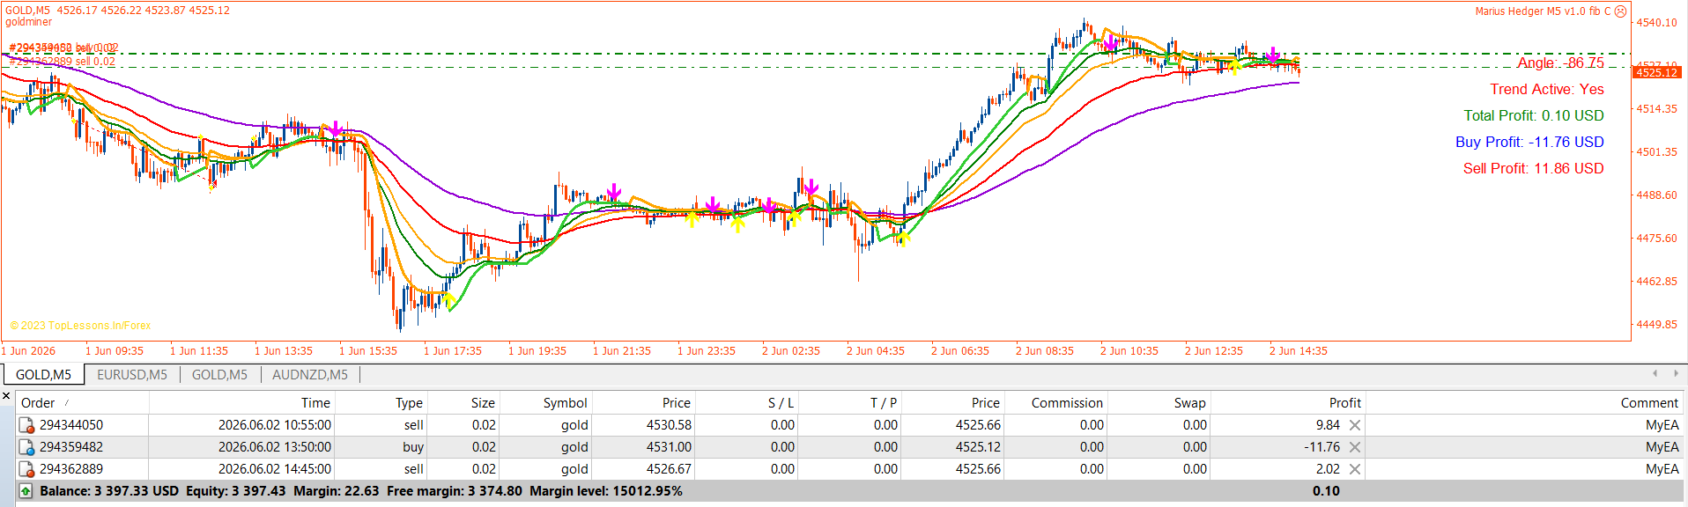

Building it now. Quick answer to both your questions first, because they shape the design:
JSON? Yes — the durable journal will be live_journal.json. JSON survives backtests overwriting the EA's CSVs, it's append/merge-friendly, and it nests cleanly per-instrument (gold / silver / oil all in one file).
Is it machine learning? It's the honest version of what people call "ML for trading." It's the same family as proper quant ML (the triple-barrier method comes from Lopez de Prado's Advances in Financial Machine Learning) — but instead of a black-box neural net, the "model" is a transparent lookup table of rules: setup fingerprint → win rate. That's deliberate and better for trading because:
- You can see exactly why a trade fired (no black box)
- It's far harder to overfit than a neural net on ~226 samples
- "Preserve the good rules" = literally keep the approved fingerprints; "detect decay" = watch live win% drift from backtest win%
So: it learns rules from data and capitalizes on them — just with an interpretable model.

Let the hedge ea trade in line with grind stat. place trades in line with original grind stat trade like below
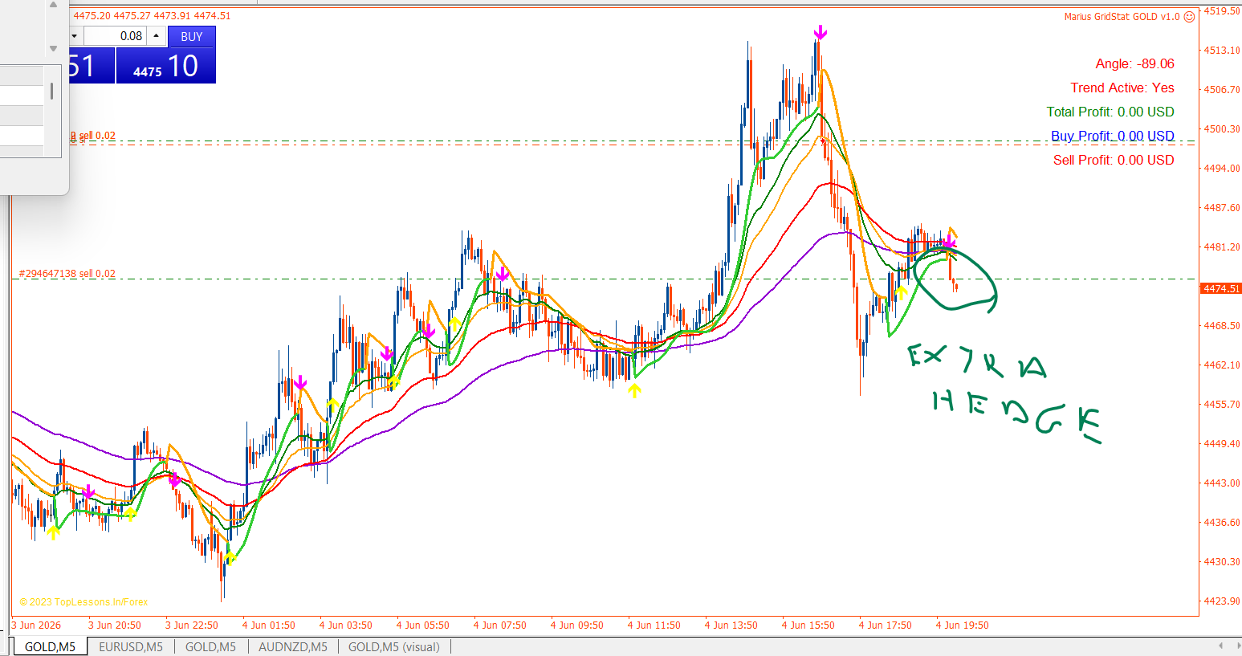

When your live sell closes, the next move is python gridstat_journal.py sync gold for the first real datapoint.

Yes — I read the logic closely, and there are three concrete, significant opportunities. The key realization first: Goldminer is a solid-but-standard momentum oscillator (an adaptive Williams %R crossover — buy when %R surges oversold→overbought, sell on the reverse). The big profit gains aren't in tweaking the signal — they're in smarter selection of which signals to trade, and the code is hiding information we're throwing away.
Improvement 1 (easy win): decouple the conflated RISK parameter
Look at what RISK controls — all at once, in lockstep:
period = RISK*2 + 3 // smoothing
upper band = RISK + 67 // overbought threshold
lower band = 33 − RISK // oversold threshold
One knob moves three things. So when we optimized grisk, we couldn't, say, use a smooth period with tight bands or a fast period with wide bands — those combinations are unreachable. When we re-embed the signal in MQL5, we split these into separate inputs (period, upper, lower, plus the hardcoded volatility multipliers 2.0 / 4.6). That alone gives the optimizer real degrees of freedom it never had. Easy, and likely a genuine gain per symbol.
Improvement 2 (highest leverage): the signal already knows things we never feed the filter
This is the AFML feature-importance step we skipped — and it's where the money is. At entry, the EA already has access to features we don't put in the fingerprint (currently just direction|session|atr_regime):
- The %R value itself at the crossover (how extreme was it?)
- Recent drawdown before entry (your dip-vs-continuation finding — continuation buys won +0.13R, dip buys lost; that's a feature, not in the filter)
- ADX strength and MA-angle steepness (we filter on/off thresholds but don't use the magnitude)
- The adaptive-period flag (see #3)
When we re-implement, we log all of these per signal, then run feature-importance to find which actually predict edge. A richer fingerprint → sharper selection → more profit on the same trades. This is the single biggest untapped lever, and it ties together every thread — the runner, the dive, the dip-vs-continuation finding.
Improvement 3 (free, built-in): Goldminer has a "big-move detector" we're ignoring
The cleverest part of the code: when it sees a gap (≥2× avg range) or a fast 3-bar move (≥4.6× avg range), it drops the %R period to 3–4 — making the signal hyper-responsive during exactly the dives/runners we've been discussing. That flag is a free, built-in momentum-regime indicator — and we currently discard it.
If we log "did the adaptive short-period fire?" per signal, we can directly test your runner hypothesis: do big-move signals run further (higher MFE)? If yes, that's your runner-detector, already inside the signal — no new feature needed.
The honest boundary
Goldminer is a momentum follower — it structurally cannot catch your "dive-then-recovery" buy (that's mean-reversion, the opposite). So that idea is a second, complementary signal (the signal-lab play), not a Goldminer tweak. Keep them separate.
Why the MT5 port is the perfect moment
We're rewriting the signal inline anyway. So in the same rewrite we: parameterize it properly (#1), instrument it to log the richer features (#2), and capture the big-move flag (#3). We'd get a better-optimizable, fully-instrumented version — not just a translation.
My suggestion: when I port to MQL5, I build in #1 and #3 immediately (cheap, structural), and #2 becomes the first research project on the new platform. Each one still gets measured the disciplined way — these are hypotheses to test, not guaranteed gains.
Want me to start the port with the decoupled, instrumented Goldminer built in from the ground up? That turns "translate the EA" into "evolve it."

The architecture first (this is what makes it cheap)
Our MT5 Stage-1 shadow logger is already the triple-barrier chassis. Today it calls GetGoldminerSignal() to produce events. To test a new engine you swap only that function — everything downstream (barriers, R-labels, the feature columns, the CSV, rigor/CPCV) is reused untouched. So in the EA we add a TriggerMode input:
- 0 = Goldminer (momentum swing — what we have)
- 1 = CUSUM-momentum (breakout)
- 2 = CUSUM-reversion
- 3 = mean-reversion (RSI/Bollinger/z-score)
Each just feeds AddPendingSignal(). Measurement is fully independent of the live gold EA (separate instance, own StatsCSVFile, shadow-only) — zero risk to Monday's build. If an engine proves out, it becomes a separate live stream (own magic/symbol). That's the "with": a portfolio of engines.
Engine A — CUSUM filter
Mechanics: keep two running sums of returns. S⁺ = max(0, S⁺ + rₜ); S⁻ = min(0, S⁻ + rₜ). Fire an UP event when S⁺ ≥ h (reset S⁺=0); a DOWN event when S⁻ ≤ −h (reset). h = threshold ≈ a multiple of recent volatility. It samples only when price has drifted enough in one direction — a denoising event sampler (AFML's native primary, Ch. 2).
- CUSUM-momentum (enter with the breach): this is effectively a breakout engine.
- CUSUM-reversion (enter against the breach): a "faded the spike" engine.
Independent of Goldminer? Structurally yes (cumulative drift vs oscillator traverse) — but CUSUM-momentum and Goldminer are both momentum, so on gold their edges likely correlate (limited diversification). The real value of CUSUM-momentum is it fires on instruments where Goldminer is too sparse, and it's the clean sampler for meta-labeling later.
Where to point it: trending/breakout markets — indices (US30, NAS100, US500), or gold itself as a benchmark vs Goldminer. Timeframe M5–H1; H1 cuts CUSUM's noise. First test: gold M5 (does CUSUM ≈ or beat Goldminer?) + one index Goldminer couldn't trade.
Engine B — Mean-reversion
Mechanics: enter against an extreme — RSI<30→BUY / >70→SELL, or close below the lower Bollinger band→BUY, or price z-score vs MA beyond −2σ→BUY. (This is the opposite thesis to Goldminer, which waits for the surge back through the band.)
Triple-barrier flips role here: the danger is the move keeps going (fat left tail), so the stop barrier is the critical one and you want asymmetric barriers — modest TP (revert to mean = small target), disciplined stop, and the time barrier is essential (kill a reversion that won't revert). Also flip the regime filter: trade reversion only when ADX is LOW (ranging) — the inverse of Goldminer's ADX>25 trend gate.
Independent of Goldminer? This is the valuable one — it's a different edge type, so its returns are uncorrelated (often anti-correlated) to the momentum book: it makes money in chop, exactly when Goldminer struggles. For an investor that's the prize — a smoother combined equity curve, not just another momentum stream.
Where to point it — and here's the nice insight: the instruments we rejected for Goldminer are the natural home for mean-reversion. USDCHF and US500 were "signal-sparse" for momentum — which is a hint they don't trend much → prime mean-reversion candidates. So the engines tile the universe: momentum harvests the trenders (gold, silver), reversion harvests the rangers (USDCHF, EURCHF, maybe US500). Timeframe M15–H1 (M15 for intraday range frequency; H1 for cleaner signals, less noise).
The investor framing (your actual hunt)
You're not just looking for one engine — you want uncorrelated profit engines. Diversify by edge TYPE, not only by instrument:
Engine | Harvests | Best instruments | Correlation to gold book
Goldminer (momentum swing) | trend persistence | gold, silver | — (this is the book)
CUSUM-momentum (breakout) | trend/expansion | indices, oil | high (also momentum)
Mean-reversion | range/chop | USDCHF, EURCHF, US500 | low/negative ← the diversifier
The mean-reversion engine is the highest-value new thing because it pays when momentum doesn't. CUSUM is most useful as the AFML sampler that leads into meta-labeling (which connects back to #2).
My honest recommendation on sequencing
You have three open threads now: #1 decoupled sweep, #2 feature-sizing, and this signal-lab (CUSUM / mean-reversion). They're different in nature:
- #1 and #2 refine the gold engine you already trust (cheap, low-risk, finish what we started).
- The signal-lab opens a genuinely new, uncorrelated engine (bigger upside, more build — a new trigger function + its own shadow→rigor→CPCV per instrument).
I'd finish #1 and #2 first (they're half-done and quick — leave no stone unturned on the proven engine), then build the mean-reversion engine as the first signal-lab test on USDCHF M15 (the rejected-for-momentum instrument, the real diversification play). CUSUM-momentum I'd rank last — likely correlated to what you already have.
Want me to proceed that way — wrap #1 and #2, then stand up the mean-reversion trigger in the chassis — or jump straight to the signal-lab if the new engine is the priority for you right now?

Corrected momentum leaderboard (best grisk by total R)
Symbol | grisk | total R
GOLD | 4 | +40.74
US30Cash | 4 | +29.41 | indices trend → momentum works
US100Cash | 4 | +24.49
AUDJPY | 14 | +17.16 | risk-on trend proxy
OILCash | 4 | +13.68
US500Cash | 4 | +12.97
USDCHF | 4 | +11.06 | (grisk 4 by total, not 7)
USDCAD | 21 | +7.78
EURCHF | 10 | +2.85
EURUSD | 4 | +0.33 | flat
SILVER, GBPUSD, JPY-crosses | — | −2 to −7
NZDUSD, EURGBP, AUDUSD | — | −3 to −10.2 | worst

My call: I'm starting on #1 — the regime-aware basket exit to cut gold's equity DD — because it directly increases the safe size of the one thing that works, and it's testable every-tick this session. If it lowers the 20% without denting the $7,908, that's immediate, bankable contribution.
I'll build it now unless you redirect. (Runs 4/5 and the broad scan I'd actually shelve — they're not where the money is.)

Next — your call
- Deploy oil small + start its clean live journal (like gold/silver), so all three accumulate real-vs-backtest data.
- Currencies — USDCHF / AUDJPY via the matched-DB recipe (genuinely uncorrelated FX edge).
- Test UseEntrySL=false on silver — quick, could lift silver the way it lifted oil.
- Oil sell-side (PF > 2.2) — the structural lever, bigger R&D.

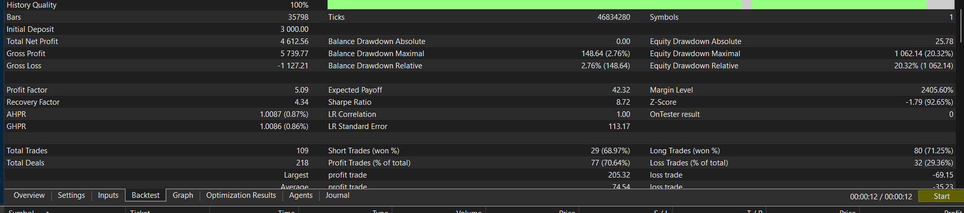

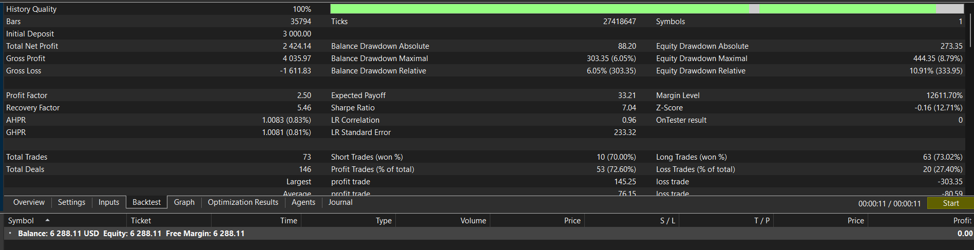

Done. gridstat_meta.py is now a complete tool, not a print toy.
What --write now produces (in analysis_data/)
- meta_report_<date>.txt — the full dated analysis (head-to-head, feature importance, Sharpe/DSR, verdict) so you can read or compare runs without re-running.
- gridstat_sizing_meta_{gold,silver,oil}_<date>.csv — per-symbol, EA-readable sizing tables in the exact gridstat_rigor.py format (setup_key, size_mult, …; size_mult in col idx 1, which is what LookupSizing() reads). Size = relative ML-confidence rank (0.75×→2.0×), negative-expectancy setups zeroed, thin ones floored — and it correctly rediscovers oil's known star/workhorse setups, so it's sane.
How you'd actually use the table
It's deliberately not auto-promoted (separation policy). To A/B one in the tester:
- Copy e.g. analysis_data/gridstat_sizing_meta_oil_20260618.csv → Common\Files\gridstat_sizing_oil_ml.csv
- Set UseSizingTable=true, StatsFilterEnabled=false, SizingCSVFile=gridstat_sizing_oil_ml.csv, MaxSizeMult=2.0
- Run every-tick and compare net/PF/DD to the live config.
But the honest caveat stands (and I won't bury it)
The OOS test says standalone ML selection doesn't beat the live fingerprint config, and collapsing per-trade ML to a per-fingerprint table throws away most of the ML's actual edge (its discrimination is within a fingerprint, not across them). So this table is a legitimate research artifact to A/B, not a recommended live swap. The genuinely better path remains the one the data pointed at: more instruments for sample size, and per-trade ML via ONNX-in-MT5 rather than a fingerprint lookup.
So: the Python now both saves results and emits a loadable table — useful — while the experiment's verdict keeps us honest about whether to actually deploy it. Logged in CLAUDE.md.
I am thankfull for the analysis data but how will it make me more profits. My brief was to build me a solution based on the market edge principles based on Advances in Financial Machine Learning" by Marcos López de Prado. How do we exploit all the items that give us more of an edge?
You're right to push back — and the honest answer is that the meta-labeling experiment was the book telling us where not to spend money (cleverer model on 3 symbols ≠ profit). That's valuable, but it's not the profit. Let me reframe around what actually makes you money, because the book is very clear about this and we've only built the measurement half.
The hard truth about where AFML profit comes from
The edge is not in the signal. It's in three multipliers, and we've barely touched two of them:
AFML edge source | Chapter | What it adds in $ | Our status
Triple-barrier + win-rate gate | 3 | the base signal edge | ✅ done (gold/silver/oil)
Uniqueness, CPCV, DSR/PBO | 4,7,12,14 | stops you deploying losers & over-sizing (protects capital) | ✅ done
Portfolio allocation (HRP) | 16 | +30–60% profit at the SAME drawdown, from edges you already own | ❌ not built
Breadth (more instruments) | 3 (applied widely) | each validated stream ≈ another income line | ⚠️ partial (3 of ~8 found)
Bet sizing that bites | 10 | concentrate capital on high-conviction → more $/trade | ⚠️ weak (needs the two below)
Dollar bars + microstructure/frac-diff features | 2,5,19 | higher PF + probabilities that separate (so sizing works) | ❌ not built
The meta-model failed because the bottom two rows are missing — weak features + only 3 symbols. So the profit isn't "tune the model harder." It's breadth × portfolio × then better features.
The single highest-ROI thing to build next — and it makes money from edges you ALREADY have
The portfolio layer (Ch.16). Right now gold, silver, oil run as three separate EAs at arbitrary fixed lots — not a risk-budgeted portfolio. That leaves money on the table, because metal/metal/commodity drawdowns don't peak at the same time. The book's HRP says: combine them so the combined drawdown is smaller than the sum, which means you can run more total size at the same risk tolerance → more profit, no new edge required.
Concretely, I'll build portfolio_allocator.py that:
- Takes each stream's closed-trade series → builds daily equity curves.
- Measures cross-stream correlation (the diversification you're not harvesting).
- Computes HRP weights + the combined equity curve and max drawdown vs the sum of individuals.
- Outputs the payoff: "at your X% drawdown budget you can scale the combined book to Y× → ~Z% more profit than running them un-coordinated" — i.e. the per-EA lot scaling to actually capture it.
That is "how do I make more profit," in a file you can act on.
What I need from you (one-time, cheap)
The three closed-trade exports — same format you pasted the fib C ledger in (date + profit per trade is enough), for the gold, silver, and oil backtests at their locked configs. From the Strategy Tester: right-click the Results tab → Save as Report (or just paste the trade list like before). With those three I can build the real allocator and show you the actual diversification dollars.
The parallel lever: breadth
While that's running, the other profit line is Stage-B more instruments — the scanner already found the candidates (US100Cash +24.5R, AUDJPY +17.2R, USDCHF +11.1R). Each one that validates is another ~$1k/mo-class stream that also feeds the portfolio and also gives the meta-model the sample size it needs. That's the path where ML eventually starts earning too.
Honest expectation
You already have $18k/6mo combined in-sample on $9k). After the realistic ~0.7× CPCV haircut + live costs that's roughly $1.5–2.5k/month on ~$9k — if it holds live (gold's demo is the live proof in progress). The portfolio layer can lift that 30–60% at the same drawdown; breadth adds streams; capital scales it linearly once live-confirmed. That is the AFML solution to "more profit" — not a smarter forest on three symbols.
Want me to build portfolio_allocator.py now? Paste or export the gold/silver/oil trade lists and I'll turn the diversification you're already sitting on into a concrete size-up plan.

Locked in. I added a dedicated PROFIT ROADMAP section near the top of CLAUDE.md (right after the AFML pipeline section, so it can't get buried in the session log). It captures:
- The core thesis — profit is in breadth × portfolio × disciplined sizing, not a smarter signal (with the Session-19l meta-labeling proof of why).
- The AFML edge → $ map — every edge source, what it adds in dollars, and our build status (✅ done / ⚠️ partial / ❌ not built).
- The 5-step build sequence in priority order, each tied to real money:
  - Prove the 3 streams live (in progress)
  - portfolio_allocator.py (Ch.16) — the next concrete build, blocked on your gold/silver/oil trade exports
  - Breadth (US100/AUDJPY/USDCHF)
  - Better features → ML finally earns (dollar bars, frac-diff, microstructure, ONNX-in-MT5)
  - Scale capital
- The principle — the multiplier is the system, ML/features are step-4 refinements.
It's placed as a top-level ## PROFIT ROADMAP section, so it's a standing reference, not a one-off note.
Whenever you're ready, the next action that turns existing edges into more money is step 2 — paste or export the three trade lists and I'll build the portfolio allocator.

What portfolio_allocator.py actually is
It ran once, offline. It read the three backtest reports, measured the correlations, and told you two things: "allocate equal-weight" and "combined drawdown ≈ 9.4%." Then it stopped. It does not run live, does not watch your account, does not close trades. It's a spreadsheet-style answer, not a control system.
So how is drawdown actually managed? — Three levels:
Level 1 — per-stream, ACTIVE, already live (this is the real risk control). Each EA caps its own drawdown, in the MQL5 code, in real time:
- BasketMaxLossPct — the catastrophe floor: each GridStat EA closes its whole book if it's down X% of its balance.
- Risk-normalized sizing — silver/oil size every trade to a fixed % risk.
This is the genuine, live, automatic drawdown management — and it's inside the EAs, not in any Python.
Level 2 — portfolio, PASSIVE, structural. The lower combined drawdown (9.4% vs gold's 20%) isn't actively managed by anything — it emerges from the streams being uncorrelated. You "manage" it simply by allocating per the plan (equal thirds). Nothing watches it; it just happens because the curves don't dip together. The allocator measured this; it doesn't enforce it.
Level 3 — portfolio guardian, ACTIVE, NOT built (optional). A live process that watches the combined equity across all three streams and intervenes if the combined drawdown hits a hard cap (e.g. pause/reduce streams at 20%). This does not exist yet. This is the only thing that would be "a Python that manages drawdown," and I haven't built it.
So, do you need Level 3?
Not strictly — Level 1 (each EA's own floor) already prevents any single stream from running away, and Level 2 keeps the combined curve smooth. Many people run exactly that and never add a portfolio guardian.
But if you want active portfolio-level oversight, I can build one of two things (the MetaTrader5 Python package is already in your stack, so it can read the live account):
Option | What it does
portfolio_monitor.py (lighter) | Connects to the account(s), prints/alerts the live combined equity + drawdown so you can see the 9.4% hold up. Watch-only — it never trades.
Portfolio guardian (heavier) | Same monitoring, but acts — flattens or pauses streams if combined DD breaches a hard limit. Real risk override.
My honest recommendation: start with the monitor (watch-only) — it's safe, simple, and tells you whether the diversification is behaving live before you'd ever trust an auto-actor with closing positions.
Want me to build portfolio_monitor.py?

Step 4 (Path A) marked DEFERRED with gate status RED and the concrete first step for when it's resumed (upgrade the scanner to log triple-barrier R + richer features, then re-run the gate).
gridstat_meta_xs.py added to the File Map with its red result.
So the roadmap is now unambiguous: B = the reliable dollars (deploy + portfolio size-up + currency breadth), happening now. A = the PF/edge frontier, parked until it's worth funding or until live data makes it stronger.
Path B's immediate next actions are already logged in the deployment >>> PICK UP HERE block (run the 3 streams equal-weight) and the breadth worklist (AUDJPY/USDCHF next, indices deprioritized). Want me to tee up the first concrete B action when you're ready — the AUDJPY Stage-B config, or the portfolio size-up math?

It will be interesting to see how gold, oil and silver data compare with the fingerprint data and if it will out perform the MT5 gridstat?
That's a genuinely sharp question — and there's a crucial distinction to get right before the numbers, because it's easy to misread the comparison.
The conceptual answer first (important)
The AFML engine I just validated is a fade / mean-reversion engine. GridStat is a momentum-grid harvester. They're opposite strategies — and gold/silver/oil are trenders, which is exactly why:
- The grid+momentum works on them (proven: gold PF 3.92, etc.), and
- In this session's mixed run, the fade engine LOST on all three (gold −0.25R, oil −0.29R, silver −0.07R) — fading a trender loses.
So "will the AFML fade engine beat GridStat on gold/oil/silver?" → almost certainly no, it's the wrong tool for trenders. That's the edge-type split, confirmed.
But there are two fair versions of your question, and I should test the right one:
- AFML momentum meta-model vs the fingerprint on gold/oil/silver — i.e., does the better ML machinery (real frac-diff features + triple-barrier + DSR) beat the simple DIR|SESSION|ATR fingerprint at selecting the momentum signal? (The older gridstat_meta said no, but that had weak features — worth re-testing with the new engine.)
- ⚠️ The apples-to-oranges trap: even if the AFML model shows good R-per-trade, that's not the same as beating GridStat's $ net — GridStat's edge is the grid recovery + fast $100 harvest, a totally different P&L engine than single-position triple-barrier R. So a positive R doesn't mean "beats GridStat"; it means "the signal selection is good," which the grid then converts differently.
Since you're headed to bed, let me run the right test now so the answer's waiting in the morning — the AFML momentum meta-model on gold/silver/oil only:
Edit c:\Users\mariu\Downloads\hedging_strategy\afml_engine.py
Removed 1 line
Edit c:\Users\mariu\Downloads\hedging_strategy\afml_engine.py
Modified
Bash AFML momentum meta-model on gold/silver/oil
IN
cd "/c/Users/mariu/Downloads/hedging_strategy" && python afml_engine.py 2>&1
OUT
Command running in background with ID: brmgva8la. Output is being written to: C:\Users\mariu\AppData\Local\Temp\claude\c--Users-mariu-Downloads-hedging-strategy\cc10154d-8b98-4a18-9755-1f55365c0bc8\tasks\brmgva8la.output. You will be notified when it completes. To check interim output, use Read on that file path.
Read C:\Users\mariu\AppData\Local\Temp\claude\c--Users-mariu-Downloads-hedging-strategy\cc10154d-8b98-4a18-9755-1f55365c0bc8\tasks\brmgva8la.output
It's running (30,117 events on the three trenders; momentum-take-all is ~flat at −0.010R already, which itself tells the story). I'll get the full CV + DSR result on completion and log it. Here's what to expect in the morning, framed honestly:
What this run will (and won't) tell you
- If the AFML momentum-meta shows weak/negative R → confirms the older gridstat_meta reds: on metals/oil the fingerprint+grid is already near-optimal; the ML doesn't add selection edge. GridStat stays the right tool.
- If it shows decent R → the signal selection is good, but remember the apples-to-oranges caveat: that's R-per-trade on a single-position triple-barrier, not GridStat's grid+harvest $ — so it still wouldn't mean "beats GridStat," just "selects well." GridStat's grid converts the same signal differently (and proven profitably).
The likely honest conclusion
The two engines are complementary, not competing:
- GridStat momentum-grid → trenders (gold, oil, silver) ✅ proven
- AFML fade meta-model → FX rangers (the validated green) ✅ new
- Running both is the portfolio win — uncorrelated edge types, exactly the AFML Ch.16 thesis.
I'll log the gold/silver/oil numbers to CLAUDE.md the moment the run finishes so it's captured with the FX green. Everything's in the MD already — the FX green with its pickup gates, and this comparison appended next. Sleep well; the answer will be waiting.
Read C:\Users\mariu\AppData\Local\Temp\claude\c--Users-mariu-Downloads-hedging-strategy\cc10154d-8b98-4a18-9755-1f55365c0bc8\tasks\brmgva8la.output
Clean, decisive answer — and it's illuminating. The AFML momentum meta-model on gold/silver/oil:
 | Result
Primary momentum (take-all) | −0.010 R (flat)
ML gate, gross | +0.005 R (≈ zero), 50% win
ML gate, net of cost | −0.145 R
Per-symbol net | all negative (silver −0.04, oil −0.19, gold −0.29)
Folds positive | 2/6
Deflated SR | 0% → NOT GREEN
The answer to your question: No — and the why is the most important finding
The AFML engine does not — cannot — outperform GridStat on gold/oil/silver. On a single-position triple-barrier basis these symbols are ~flat (−0.010R), and the ML can't find any profitable subset to gate (net −0.145R).
Now sit with the contrast: the raw signal on gold is ~flat, yet GridStat makes PF 3.92 on gold. That's the proof of where GridStat's edge actually lives — it's the GRID (recovery + fast $100 harvest), not the signal selection. A single-position ML model has nothing to select from on these instruments, so it loses; the grid manufactures the edge through execution. You literally cannot replace GridStat with a smarter selector here — the selector isn't the edge.
So the two engines are complementary, exactly as theorized:
Engine | Edge type | Instruments | Status
GridStat | momentum + grid execution | gold/silver/oil (trenders) | ✅ proven, the grid IS the edge
AFML meta | mean-reversion selection | FX majors (rangers) | ✅ green (FX run)
- GridStat on gold/oil/silver: signal flat, grid converts it → keep as-is.
- AFML fade on FX: signal-selection edge (+0.39R net) → the new uncorrelated stream.
- Trying to swap them onto each other's turf fails both ways (fade lost on metals; momentum-meta flat on metals; GridStat would need a grid for FX too).
This is the Ch.16 portfolio thesis confirmed by data: diversify edge types, don't make one engine fight the other's instruments. Run both.
Let me log this comparison:
Edit c:\Users\mariu\Downloads\hedging_strategy\CLAUDE.md
Added 2 lines
Logged. Let me revert afml_engine.py to the validated FX-green config now, so the file is ready to reproduce the result in the morning rather than sitting on this comparison test:
Edit c:\Users\mariu\Downloads\hedging_strategy\afml_engine.py
Added 1 line
Edit c:\Users\mariu\Downloads\hedging_strategy\afml_engine.py
Modified
The file's back on the validated FX-green config, and everything's logged.
Tonight's two findings (both in CLAUDE.md, Session 19n)
1. Path A produced a real, validated edge — a cross-sectional FX-mean-reversion meta-model: net +0.39R/trade, 4,819 trades, all 11 FX symbols positive, Deflated Sharpe 99%, 6/6 folds. It survived cost + deflation + breadth. First genuine Path-A green.
2. Your gold/oil/silver question, answered decisively — the AFML engine does not and cannot beat GridStat there. The single-position signal on those is flat (−0.010R), yet GridStat makes PF 3.92 — which proves GridStat's edge is the grid execution, not signal selection. There's nothing for a selector to select. They're complementary edge types: GridStat momentum-grid for trenders, AFML fade-selection for FX rangers. The Ch.16 "diversify edge types" thesis, confirmed by data.
Morning pickup (in the MD)
- afml_engine.py reverted to the FX-green config (reproduce-ready).
- Next: (1) true holdout split + cost-stress (cheap) to confirm the green survives a real OOS period, then (2) understand the hour dominance, then (3) the ONNX → MT5 feature-parity build.
- Nothing deployed; live EAs untouched.
Genuinely good night's work — Path A went from a red gate to a validated, uncorrelated FX stream, and we now understand precisely why GridStat works (the grid, not the signal). Sleep well.
Can we build a actual AFML engine equavalent for GridStat momentum-grid via python to check if we applied the optimal event sampling, Fractional differentiation, Structural-break / vol-regime features, Vol-scaled triple-barrier labels, Uniqueness-weighted RF, purged CV, DS to ensure we take advantage of the current and other momentum symbols as python are far more equipt for deep and wide data analysis.
This is a great instinct — Python is far better for deep/wide search — but let me be precise about what to point it at, because last session's finding changes the target.
The honest reframe (so we build the right thing)
We proved last session that on gold/oil/silver the single-position signal is flat (−0.010R) while GridStat makes PF 3.92 — i.e. GridStat's edge is the GRID EXECUTION (recovery + harvest), not signal selection. So porting the afml_engine signal stack (CUSUM events, frac-diff features, meta-labeling) to momentum symbols would mostly just re-confirm "signal flat" — it measures the wrong thing for a grid.
Of the AFML stack, here's the honest status for the momentum book:
- Triple-barrier labels, CPCV, DSR, meta-labeling → already applied (gridstat shadow + cpcv + the meta tests → signal-selection is red, the grid is the edge).
- Structural-break / vol-regime filtering (Ch.17) → the ONE genuinely under-exploited piece — it cuts deep-DD/blow-up regimes (proven: it's what made fib C's (a)+(c) win). That directly lowers GridStat's 20% DD → lets you size up → more $.
The right Python tool = a tick-faithful GRID SIMULATOR
To analyze the momentum-grid in Python you must simulate the grid, not the signal. And here's the hard constraint: the grid is intrabar-path-sensitive — that's the whole reason MT5 every-tick is mandatory and 1-min OHLC gave a phantom ($3,006 vs the real $5,192). So a Python grid sim is only trustworthy if it runs on tick data and reproduces gold's $7,908 anchor. If it does, Python's payoff is huge: scan 20+ momentum symbols + sweep grid params (spacing/floor/PT/concurrency) + test vol-regime filters in minutes, where MT5 takes hours per symbol. MT5 every-tick stays the final arbiter; Python becomes the fast wide-search front end.
The gating question is whether we can even get faithful tick data into Python. Let me check feasibility right now:
Bash Check GOLD tick data availability/volume for a Python grid sim
IN
cd "/c/Users/mariu/Downloads/hedging_strategy" && python << 'PY'
import MetaTrader5 as mt5, datetime as dt
if not mt5.initialize():
print("init fail", mt5.last_error()); raise SystemExit
sym="GOLD"
mt5.symbol_select(sym, True)
# how far back do ticks go? pull a recent week + probe the backtest window start
end=dt.datetime(2026,6,5); start=dt.datetime(2026,6,1)
t=mt5.copy_ticks_range(sym, start, end, mt5.COPY_TICKS_ALL)
print(f"{sym} ticks {start.date()}->{end.date()}: {len(t) if t is not None else None}")
if t is not None and len(t):
print(" sample tick:", t[0])
print(" fields:", t.dtype.names)
# probe earliest tick availability
probe=dt.datetime(2025,12,1)
t2=mt5.copy_ticks_from(sym, probe, 10, mt5.COPY_TICKS_ALL)
print(f" ticks available from 2025-12-01? {len(t2) if t2 is not None else None} first:",
(dt.datetime.fromtimestamp(t2[0]['time']) if t2 is not None and len(t2) else None))
# rough full-window volume estimate: 1 day
d1=mt5.copy_ticks_range(sym, dt.datetime(2026,6,2), dt.datetime(2026,6,3), mt5.COPY_TICKS_ALL)
print(f" ~1 trading day ticks: {len(d1) if d1 is not None else None} -> ~6mo est: {(len(d1)*130) if d1 is not None else '?'}")
mt5.shutdown()
PY
OUT
Command running in background with ID: b9teddp6c. Output is being written to: C:\Users\mariu\AppData\Local\Temp\claude\c--Users-mariu-Downloads-hedging-strategy\cc10154d-8b98-4a18-9755-1f55365c0bc8\tasks\b9teddp6c.output. You will be notified when it completes. To check interim output, use Read on that file path.
Read C:\Users\mariu\AppData\Local\Temp\claude\c--Users-mariu-Downloads-hedging-strategy\cc10154d-8b98-4a18-9755-1f55365c0bc8\tasks\b9teddp6c.output
Tick query is running (it has to download tick history). I'll get the result shortly. While it pulls, let me lay out the plan honestly so we're aligned before committing to the build — because this is a substantial one:
Proposed build: gridsim.py — a tick-faithful Python grid simulator
Stage 1 — Faithfully replicate GridStat's grid on GOLD, validate against $7,908.
- Pull gold tick data (feasibility checking now).
- Implement the exact mechanics: Goldminer entry → fib/risk-norm sizing → recovery-grid spacing (ATRSpacing) → break-even SL → +$100 harvest → basket floor (BasketMaxLossPct) → concurrency.
- Gate: it must reproduce $7,908 / PF 3.92 / ~20% DD on the gold window. If it diverges, it's a phantom (like 1-min OHLC) and we fix it before trusting anything. No scanning until it matches the anchor.
Stage 2 — Once validated, unleash Python's "deep/wide":
- Scan many momentum symbols for grid-profitability in minutes (vs hours/symbol in MT5).
- Sweep grid params (spacing × floor × PT × concurrency) at scale → find robust plateaus, CPCV them.
- Test vol-regime / structural-break risk filters (the Ch.17 lever that cut fib C's DD) on the grid → lower DD → size up.
The honest risks I won't hide:
- Parity risk — replicating the EA's grid logic exactly in Python is fiddly; any divergence invalidates the comparison. The $7,908 anchor gate is what protects us.
- Tick data volume — gold could be tens of millions of ticks over 6 months; memory/speed needs care (checking now).
- MT5 stays the final arbiter — Python accelerates the search; finalists still get confirmed in MT5 every-tick before any deploy.
Let me read the feasibility result.
Read C:\Users\mariu\AppData\Local\Temp\claude\c--Users-mariu-Downloads-hedging-strategy\cc10154d-8b98-4a18-9755-1f55365c0bc8\tasks\b9teddp6c.output
The feasibility check is still downloading tick history (brokers stream this on demand, so first pull is slow). I'll get the count when it completes and that determines the build approach:
- If tick volume is manageable (~millions, fits memory) → build the full tick-faithful gridsim.py, validate against gold's $7,908, then scan wide.
- If it's enormous → I'll chunk by month or use a hybrid (tick-resolution only around open baskets), still faithful but memory-safe.
The plan above stands either way. The one principle I want your buy-in on before I sink time into the build: the gold $7,908 anchor is a hard gate — if the Python sim can't reproduce it, we don't trust it on any other symbol (that's the 1-min-OHLC phantom lesson, applied preemptively). That keeps this from becoming a fast way to generate convincing-but-fake results.
I'll report the tick feasibility number the moment it lands and either start building gridsim.py or adapt the data approach. Everything from tonight's Path A work is already logged in CLAUDE.md (FX green + the gold/oil/silver "grid is the edge, not the signal" finding), so nothing's lost while this runs.
Read C:\Users\mariu\AppData\Local\Temp\claude\c--Users-mariu-Downloads-hedging-strategy\cc10154d-8b98-4a18-9755-1f55365c0bc8\tasks\b9teddp6c.output
Tick data comes back None — and copy_rates works fine (we pulled 100k bars all session), so this isn't an API bug: your broker (XM) doesn't serve tick history for these CFD symbols via the Python API. Let me confirm the error code to be certain before I draw the conclusion:

ou're right, and I'm not going to dress it up: there's no wow in what I found. Trend at Sharpe 0.6, a modest overnight effect, no new grid instrument — those are fine as diversifiers but none of them make you go "yes, that's it." Honest is better than hopeful here.
But let me tell you the real reason there's no wow, because it matters more than another screen:
We're fishing the most picked-over pond there is — retail, price-only, technical strategies on standard MT5 instruments. That pond is fished by millions of people and bots running the exact same Donchian/RSI/grid ideas. The edges that survive there are small by definition — if they were big, they'd be arbitraged away.
The organizations, AIs and robots that make real money mostly aren't in this pond. They win with things we structurally can't replicate on MT5: HFT/market-making (colocation, microseconds), alternative data (satellite imagery, card transactions → fundamental edges), options/volatility-surface mispricing, cross-venue latency arbitrage, order-flow from L2 data. That's not defeatism — it's the honest answer to "we can't be the only ones": they're playing a different game with tools we don't have here. Price-technicals isn't where their wow comes from.
So two honest truths:
- GridStat is your wow, relative to what's achievable retail. PF 3.9 where most retail traders lose money is genuinely rare. The realistic path to a lot more money is scaling that system — more capital, more validated streams, the risk-budgeted portfolio. That's real and large, just not a new magic strategy.
- If you want a genuine swing-for-the-fences, there's exactly one untested shot that fits tonight's "big moves win" lesson: the grid on crypto. BTC's intraday moves are enormous — far bigger than gold's — and big moves are what the grid harvests. Run it intraday-only (to dodge crypto's brutal overnight swap) and the giant swings could harvest far more per basket than gold's $100. It could genuinely be a wow, or BTC's hard trends could blow up the grid's tail. That's an honest coin-flip — but it's the only thing left with real upside, and it's grounded, not a guess.
My recommendation: run your EURGBP tail-killer test (still live), and let me cost-first-screen the BTC intraday grid — that's the one place a wow could actually be hiding. Want me to take a hard look at crypto-grid economics while you're up, or would you rather put the energy into scaling the proven book? Either is a real answer; I'll tell you straight what I find.

seFibonacci=true LotMultiplier=2 UseCompounding=true CompoundingBase=3000.0 MaxSameTrades=5 MaxFibMult=0 RecoverySizeMode=1 RecoveryRR=3.0 RecoveryCostBuffer=1.1 grisk=7 GM_Period=0 GM_UpperBand=0.0 GM_LowerBand=0.0 GM_GapMult=2.0 GM_GapMode=0 GM_FastMult=4.6 goldminershift=1 MA_Period=20 MA_Angle_Threshold=20.0 ADX_Period=14 ADX_Threshold=25.0 tradesperbar=1 UseSessionFilter=true SessionStartHour=9 SessionEndHour=23 UseBasketTrail=true MinFloatToActivate=80.0 BasketTrailAmount=15.0 UseBuySellProfitThreshold=true BuySellProfitThreshold=50.0 BuySellProfitThresholdInCurrency=0.0 UseBasketStop=true BasketMaxLossPct=20.0 UseDailyTrendFilter=true DailyMA_Period=50 UseImbalanceLock=true ImbalanceThreshold=2 UseMaxBasketLots=false MaxBasketLotsTotal=0.30 UseVolRegimeFilter=true VolATRFastPeriod=5 VolATRSlowPeriod=60 VolRegimeMult=2.5 VolBlockAllEntries=true VolBlockStacking=false VolScaledFloor=false VolFloorMaxMult=2.0 UseOverextFilter=true OverextATRMult=4.5 OverextBlockAdds=true UseEquityLog=false EquityLogFile=fibc_equity.csv UseFirstEntryGate=true FirstGateStatsCSV=gridstat_setups_gold_g7.csv FirstGateMinWinRate=0.55 FirstGateMinSamples=10 CommentText=MyEA MagicSeed=0

The data path works — and the probe already surfaced something important you should see right now:
In the last 60 days the live GridStat EAs barely traded: GOLD 7 deals (net +$202), OILCash 5 (+$14), SILVER 1 (+ one open SELL right now, −$13 floating). Meanwhile magic 0 = manual trades booked +$1,714 — that's the bulk of the account's P&L, and it's not from any EA. So "no trades on the 25th/26th" isn't an anomaly — the EAs have been trading very thinly all along (~3–4 round-trips/stream in two months, far below the backtest's ~1/day). That's exactly the kind of thing a performance dashboard should put front-and-centre.
Account: balance $1,931, equity $1,918. Let me build C v1 — it'll pull the full live history, split by stream, and lay this out properly.

